

**Jumping Animals**

**Thank you for purchasing the asset , if you have any question please contact me at** [**madfireongames@gmail.com**](mailto:madfireongames@gmail.com)

**Project Structure**

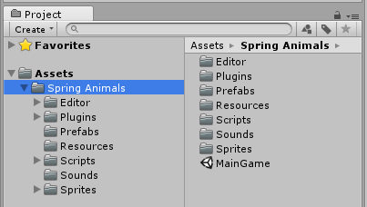

**Animations folder**: There is stored animations used in game.

**Editor Folder**: There is stored Game Design window script (Dont edit anytging in this folder).

**Fonts folder**: There is stored fonts used in GameScene.

**Texture2D**: There is stored all sprites and textures used in game.

**Materials:** There is store material of GameObjects used in game.

**Prefabs Folder**: There is stored Game Objects spawned in game.

**Resources Folder**: There is stored resources for Game Design (Dont edit anytging in this folder).

**Scripts Folder**: There is stored Script files used in game.

**Sounds Folder**: There is stored Musics and Sound effects used in game.

**Scripts**

1. GameManager:- This script controls the game , its saves and loads data from the device eg:- Best Score , musics status ,etc.

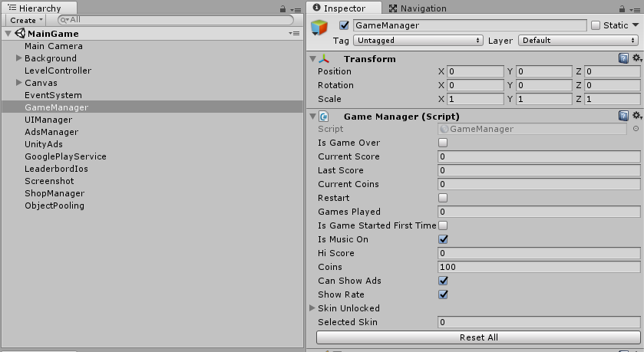

1. Leaderboard:- Scripts which control leaderboard of play store and app store.

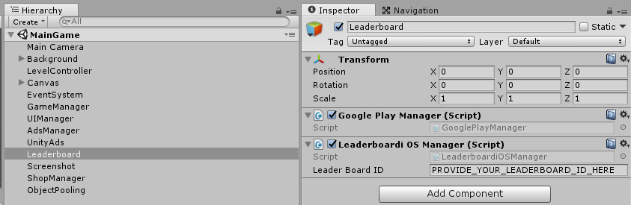

1. Unity IAP:- This script controls the Unity IAP for android and iOS. It controls the remove ads function.

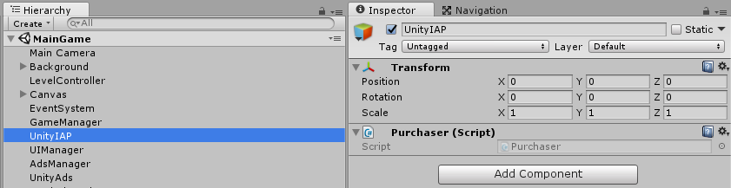

1. UIManager:- This script controls the game menu , assigns the functions to the buttons and updates the text like score , best score , etc;

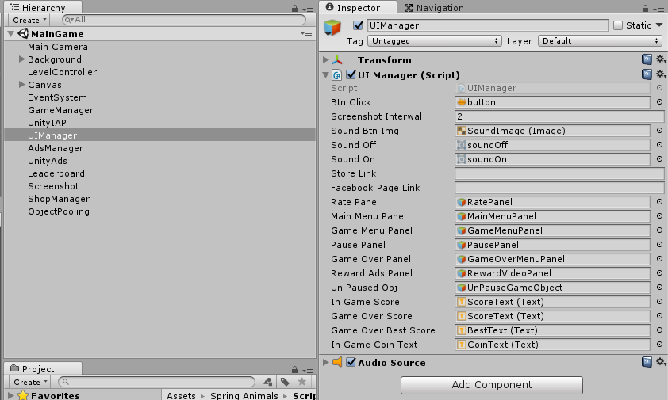

1. ShopManager:- This script controls the shop menu , is assigns the functions to the buttons and updates the character , etc.

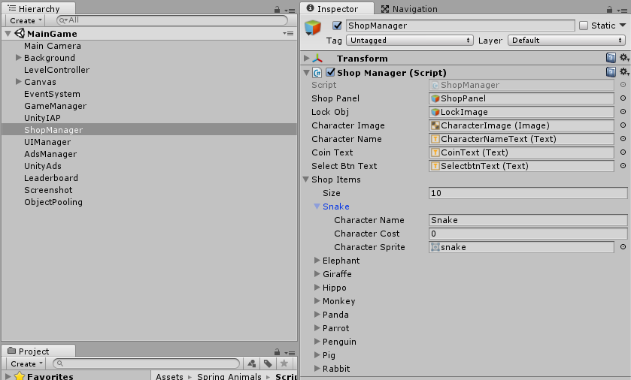

1. ObjectPooling:- This script created the required clone of objects which are used again and again and it the make them active when required , helps in game optimization.

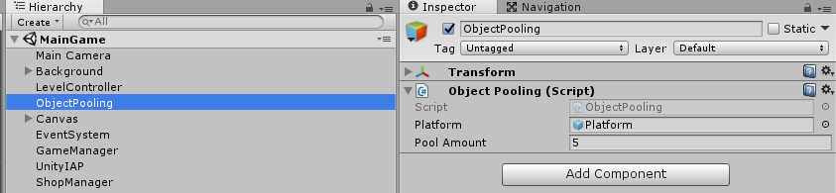

1. ScreenShot:- This script helps player to take the screen shot of their game and share it on the social platforms like facebook , whatsapp , etc.

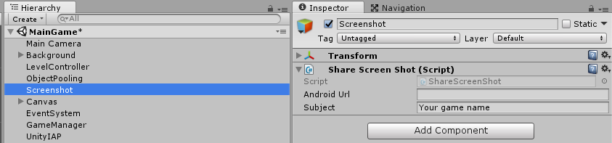

1. LevelController:- This script controls the spawning of platform , player , there path and much more.

